June 30, 2015
Volume 2: Issue 4
——————————————

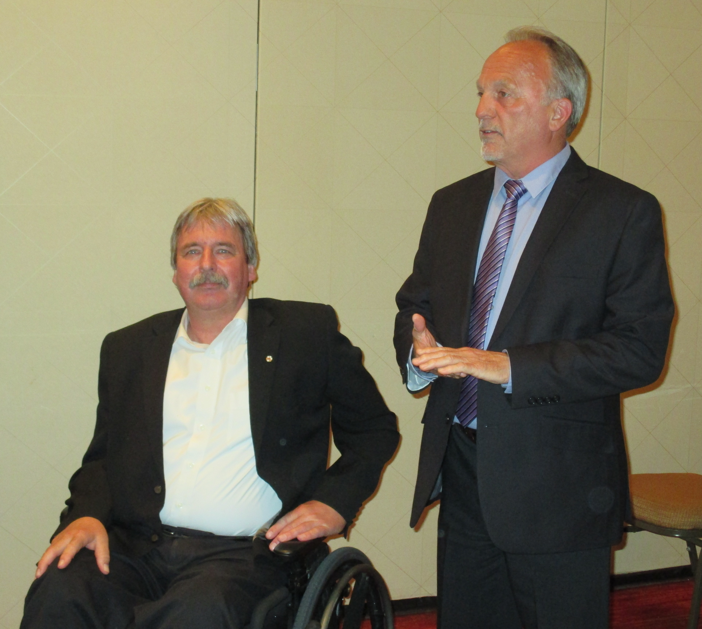

Western Forest Products Contribution to PCU-WHS

June 2015 – The Board of Governors of Pacific Coast University for Workplace Health Sciences are pleased to announce that Western Forest Products (WFP), a large integration forest products company operating on Vancouver Island, has provided a significant contribution enabling the University to commence development work on additional degrees.

“As the founding sponsor for the creation of an ‘International Bachelor Degree in Integrated Workplace Health’, we are extremely pleased that WFP has taken this leadership step,” said Wolfgang Zimmermann, PCU-WHS President, "as this will allow us to not only start additional course development work, but also to build partnerships with other companies, unions and governments towards creating a unique educational curriculum designed to meet key challenges facing workplaces in British Columbia, in Canada, and around the world.”

“Initial course development is only the first step in a long process towards offering a high-quality degree, an approval framework superintended by the BC Ministry of Advanced Education; nevertheless, WFP's support is key in allowing us to formally launch this new initiative."

"Health and safety is a core value at the foundation of everything we do and supporting the expansion of additional educational opportunities in this field is a logical expansion of this core value," said Mike Cass, Vice-President, Human Resources for WFP in announcing the funding support. "But additionally, our company has a long and distinguished history of operating in the Alberni Valley, which continues to date. We are also hopeful that through our support, others will be encouraged to participate in a very worthwhile effort to reduce injuries and improve return to work outcomes".

About Pacific Coast University for Workplace Health Sciences
Pacific Coast University for Workplace Health Sciences is a non-profit, special-purpose university headquartered in Port Alberni, British Columbia, and established through an act of the provincial legislature. PCU-WHS is a statutory degree granting education and research institution for the special purpose of creating and disseminating new knowledge including applied research in the fields of return to work and disability management, workplace safety, health promotion, comprehensive rehabilitation and disability leadership studies. Programs are delivered with online technologies that allow adult learners with multiple commitments to carry out most study activities in their home location at the time, place and place that best suits their needs.

Contacts:
For more information on PCU-WHS, please contact us as follows:
Tel: 778-421-0821
Email: info@pcu-whs.ca
Web: www.pcu-whs.ca

